**Milestone Project**

**An Analysis of Career Trajectories: Salary & Experience Across Global Industries**

*Insight Project Report*

Submitted By

NIRANJANA KS

10/08/2025

DATA ANALYTICS & DATA SCIENCE

Batch: May-2025

**1.Introduction**

The dataset, titled "Salary Survey 2021," contains detailed salary and employment information from various professionals across multiple industries. It includes 28104 rows and 16 columns covering key attributes such as age range, industry, job title, annual salary, additional monetary compensation, currency, country, state, city, years of professional experience, highest education level, and gender. The data spans diverse sectors like education, technology, healthcare, law, nonprofits, and more, with salaries reported in different currencies (e.g., USD, GBP, CAD). This dataset provides valuable insights into compensation trends, demographic distributions, and the impact of factors like experience and education on earnings. It is useful for analyzing salary disparities, industry benchmarks, and regional variations.

**2.Project Objective**

The primary objective of this project is to perform an end-to-end analysis of global salary data to uncover key trends and patterns in compensation structures across industries, job roles, experience levels, and demographics. By leveraging tools such as Excel, SQL, and data visualization techniques, the project aims to deliver actionable insights that can inform stakeholders about the factors influencing employee earnings across different regions and professional backgrounds. This project simulates a real-world data analysis lifecycle, starting from raw data cleaning to generating meaningful business insights through dashboards and reports.

**Key Goals:**

• **Understand Salary Distribution** across industries, job titles, countries, education levels, and genders.

• **Analyze Additional Compensation Trends** like bonuses and commissions based on job roles and gender.

• **Identify High-paying Roles and Locations** to help guide professionals in career decisions.

• **Evaluate the Impact of Experience and Education** on salary levels and career progression.

• **Develop Interactive Dashboards** using Excel that allow real-time filtering and comparison.

• **Apply SQL Queries** to extract insights from structured data efficiently.

• **Document and Communicate Findings** in a professional format for stakeholders.

**3.Dataset Description**

The dataset contains information on salaries, industries, job roles, and additional compensation.

**Total Records:**

• Number of Entries: 28,104 records

• Number of Attributes: 16 columns

**The key attributes include:**

* **Age Range**: The age group of the individual.
* **Industry**: The sector in which the individual works.
* **Job Title**: The individual’s position.
* **Annual Salary**: The individual's yearly earnings.
* **Additional Monetary Compensation**: Bonuses, commissions, stock options, etc.
* **Currency**: The currency used in salary reporting.
* **Country, State, and City**: Geographical location of employment.
* **Years of Experience**: Both total and industry-specific experience.
* **Highest Level of Education Completed**: Academic qualifications.
* **Gender**: The gender identity of the individual.

**4. Tools Used:**

* Excel
* SQL

**5. Data Cleaning & Preprocessing**

To ensure the quality and reliability of analysis, the original salary survey dataset underwent a comprehensive data cleaning and preprocessing phase. This step addressed missing data, inconsistencies, format variations, and extreme outliers, ultimately resulting in a well-structured and analysis-ready dataset. To prepare the dataset for analysis, key cleaning steps were performed:

• **Missing Values:** Replaced blanks in Job Title, Industry, and Gender with "Unknown". Filled null Annual Salary values using the median.

• **Format Standardization:** Fixed inconsistent casing (e.g., "usa" → "USA"), standardized currency codes (e.g., "usd" → "USD").

• **Inconsistencies:** Merged variations like "US", "USA", and "United States" into a unified format.

• **Outlier Handling:** Removed or capped unrealistic salary entries above $500,000 unless contextually valid.

Row Data:

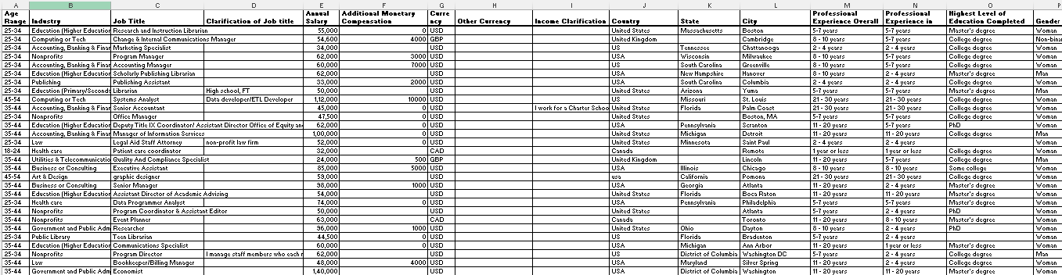

Cleaned Data:

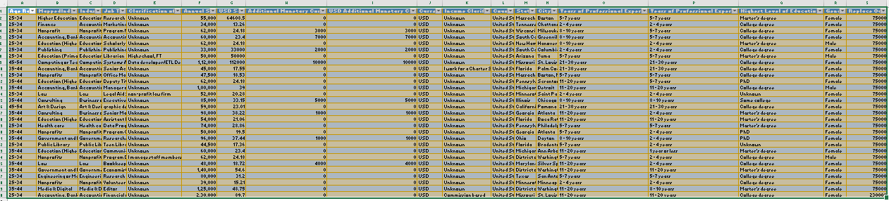

**6. Data Import into MySQL**

- Created database: ` salary_survey_dataset`

- Created table: ` cleaned_data_sql` with appropriate data types.

- Imported cleaned data using MySQL Workbench tools.

- Exported SQL query outputs to CSV files.

- Created individual sheets in Excel for each query. Named: ‘Salary_Survey_2012_Full’

**7. SQL Queries & Results**

**1. Average Salary by Industry and Gender**

Compare the average salary within each industry, split by gender. This helps identify potential salary discrepancies based on gender within industries.

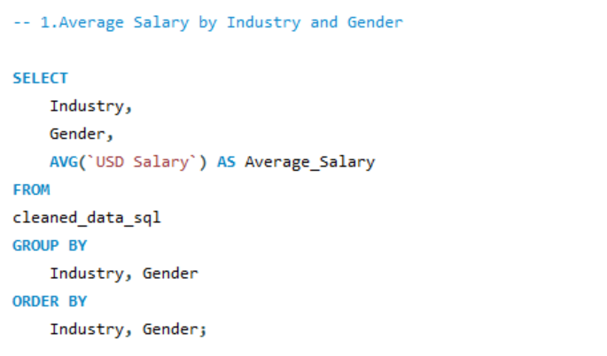

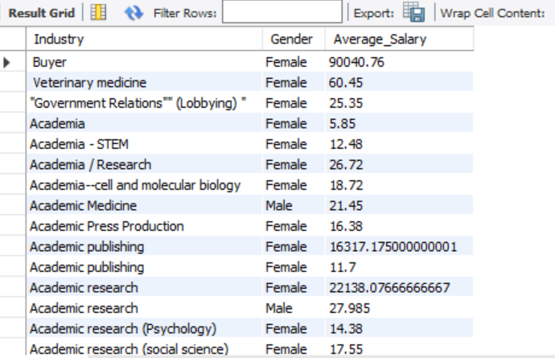

1. **Total Salary Compensation by Job Title**

Find the total monetary compensation (base salary + additional monetary compensation) for each job title. This can show which roles have the highest overall compensation

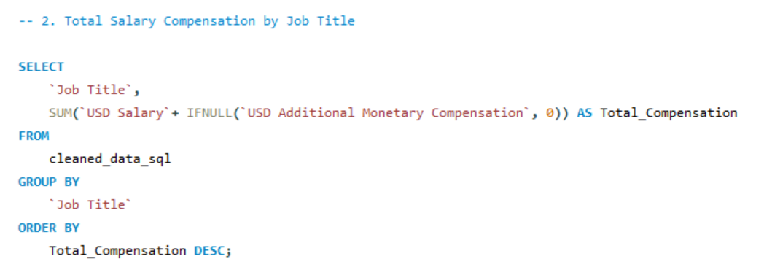

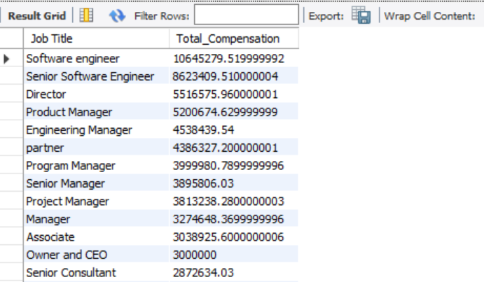

1. **Salary Distribution by Education Level**

Find the salary distribution (average salary, minimum, and maximum) for different education levels. This helps analyze the correlation between education and salary.

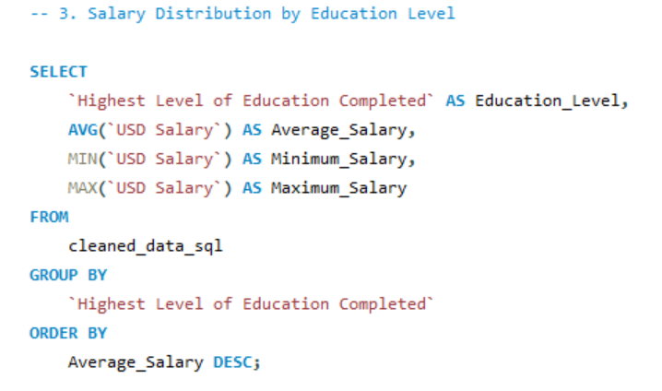

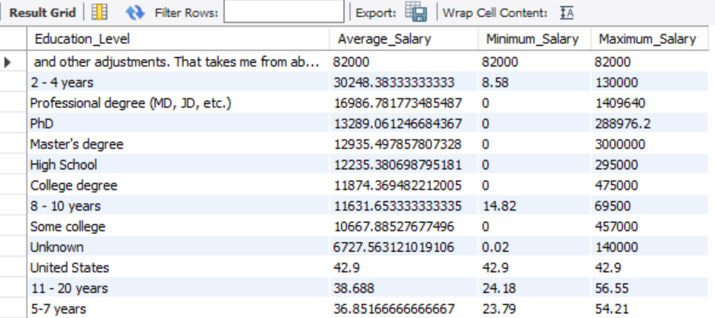

1. **Number of Employees by Industry and Years of Experience**

Determine how many employees are in each industry, broken down by years of professional experience. This can show if certain industries employ more experienced professionals.

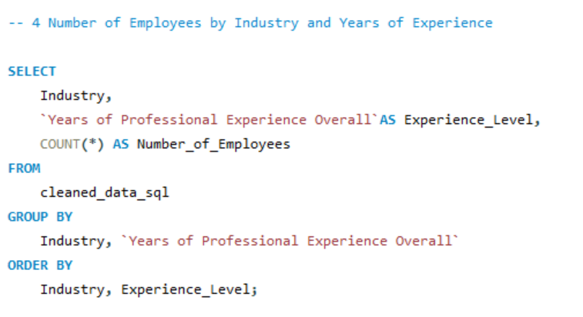

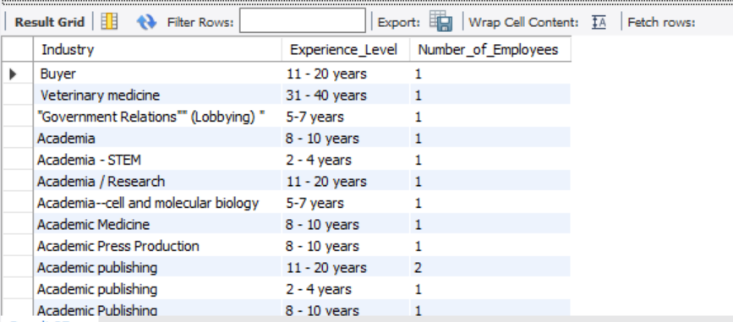

1. **Median Salary by Age Range and Gender**

Calculate the median salary within different age ranges and genders. This can provide insights into salary trends across different age groups and gender

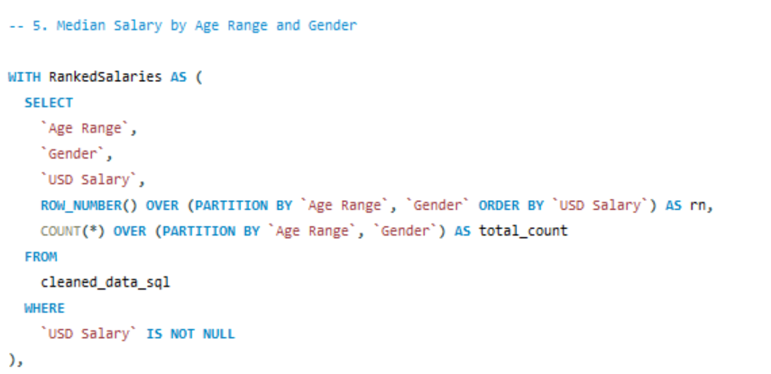

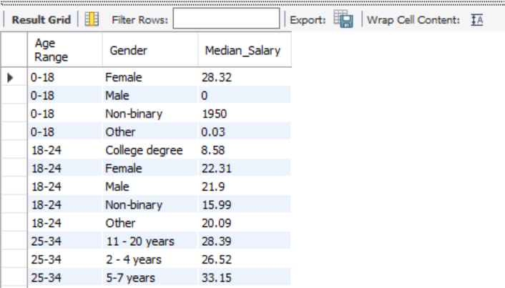

1. **Job Titles with the Highest Salary in Each Country**

Find the highest-paying job titles in each country. This can help understand salary trends across different countries and highlight high-paying positions

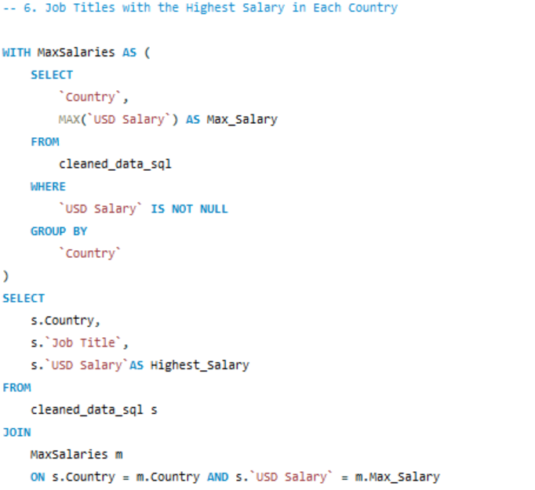

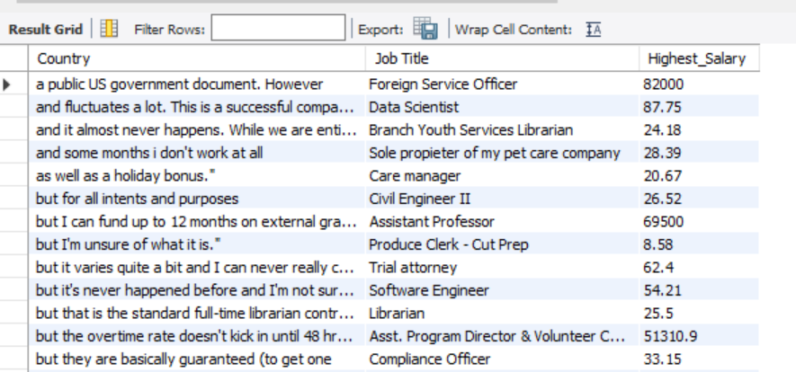

1. **Average Salary by City and Industry**

Calculate the average salary for each combination of city and industry. This shows which cities offer higher salaries within each industry.

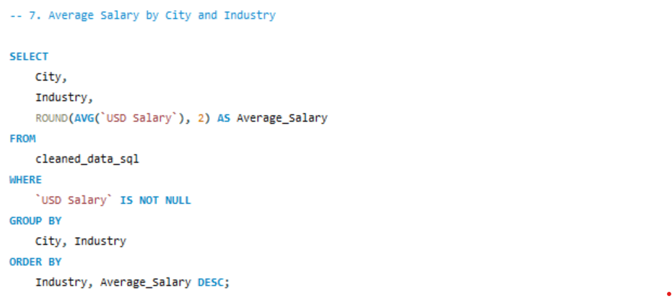

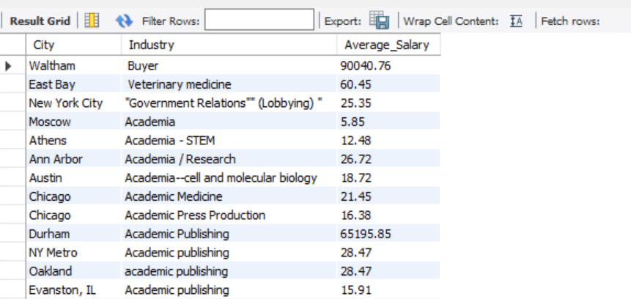

1. **Percentage of Employees with Additional Monetary Compensation by Gender**

Find the percentage of employees within each gender who receive additional monetary compensation, such as bonuses or stock options

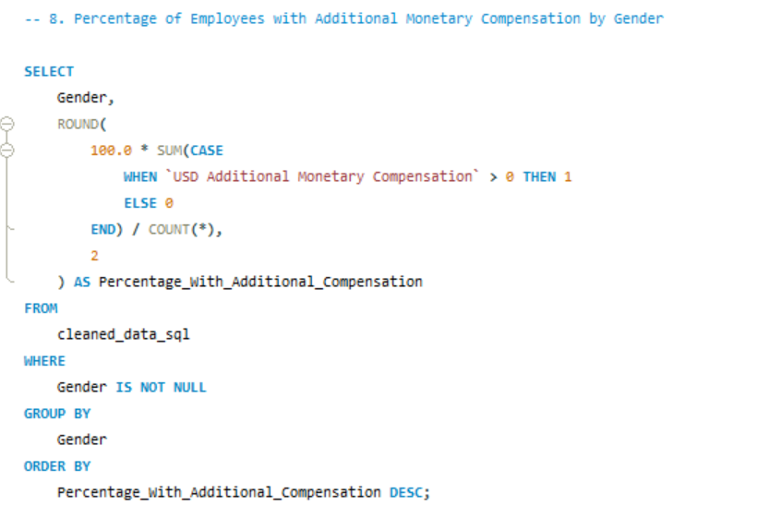

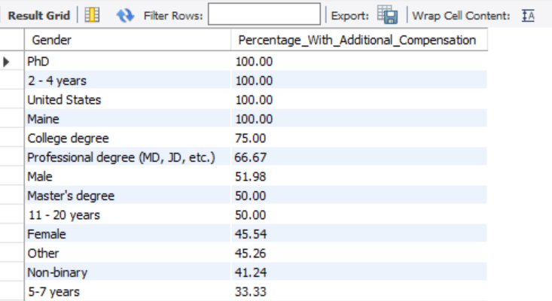

1. **Total Compensation by Job Title and Years of Experience**

Determine the total compensation (salary + additional compensation) for each job title based on years of professional experience. This can help highlight compensation trends based on experience levels within specific job titles.

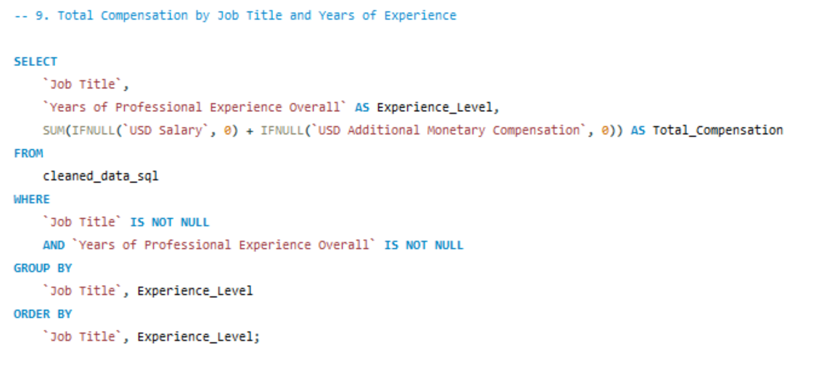

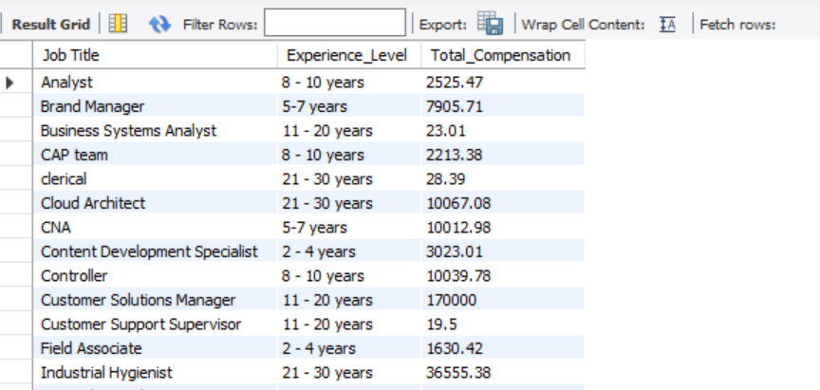

1. Average Salary by Industry, Gender, and Education Level

Understand how salary varies by industry, gender, and education level. This query can provide a comprehensive view of how multiple factors influencesalary.

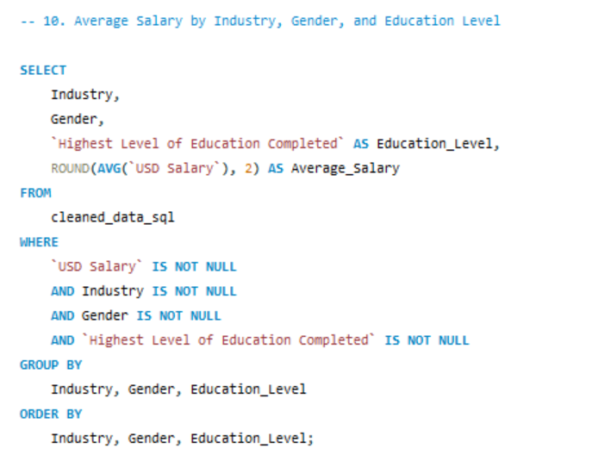

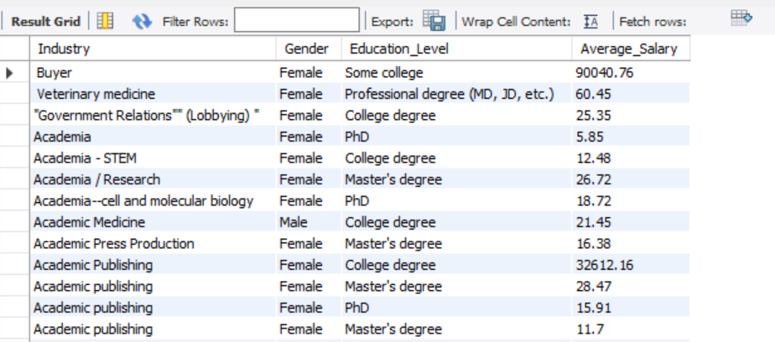

8.**Pivot Tables and Charts:**

1.Average Salary by Industry and Gender:

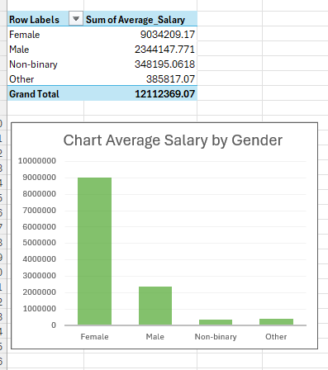

2.Total Compensation by Job Title

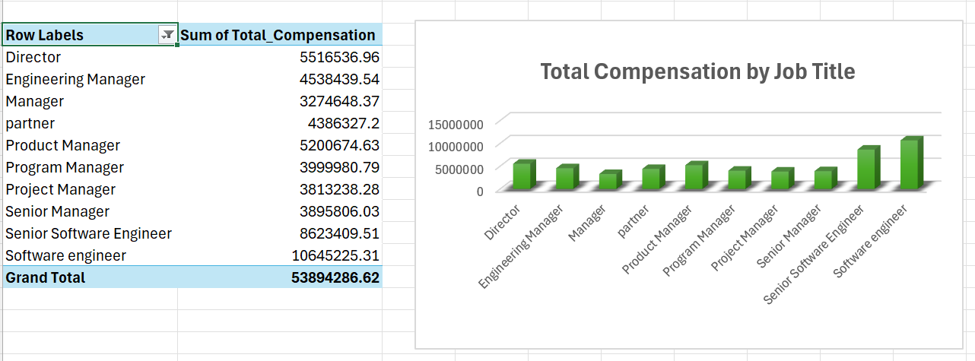

3.Education Wise Average Salary

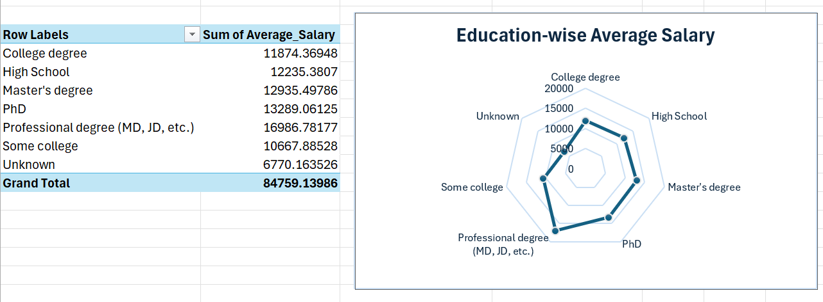

4.Number of Employees by Industry and Experience Level

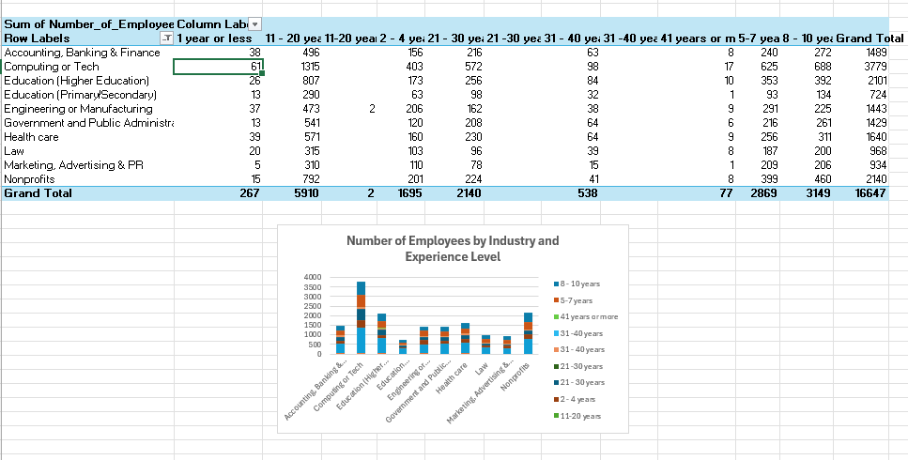

5.Median Earnings Across Age Groups

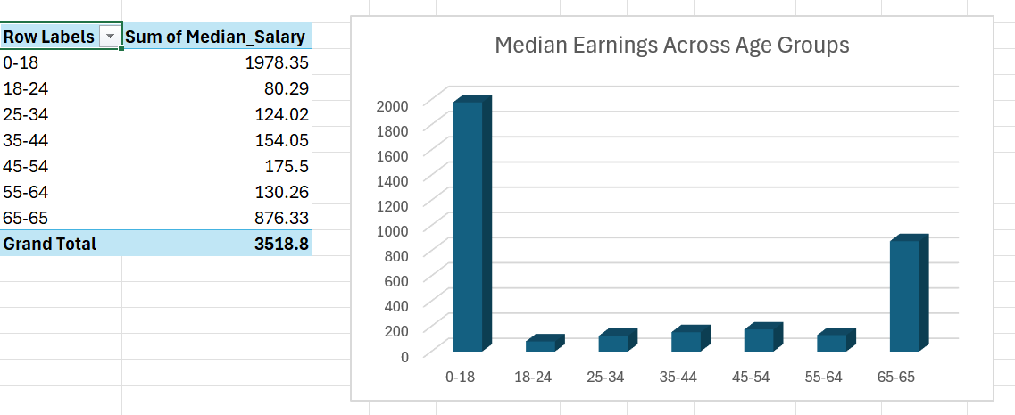

6.Top Salary Across Countries

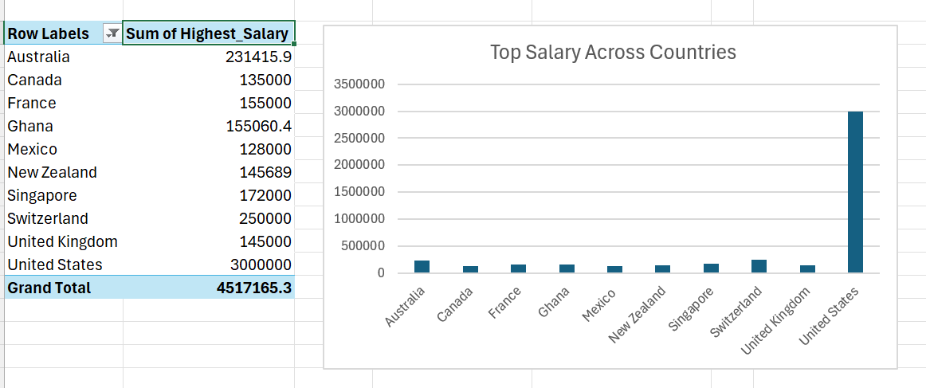

7. Industry-wise Average Salary

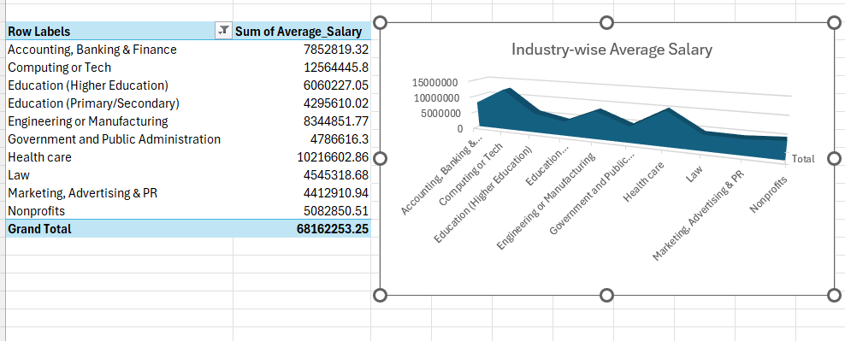

8.Gender-Wise Additional Compensation

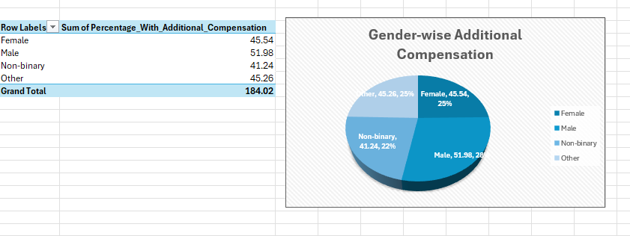

9.Compensation By Experience Level

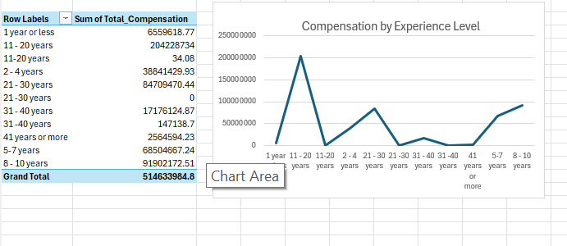

10.Average Salary By Industry and Gender

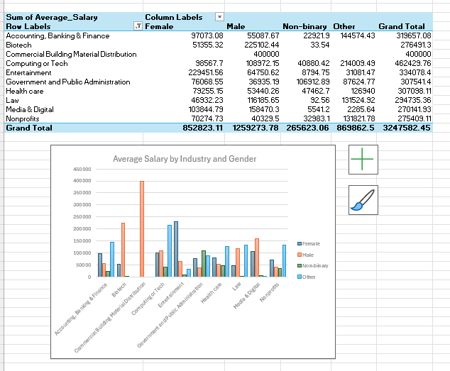

**9.Dashboard:**

Align charts and slicers in Dashboard for visualization

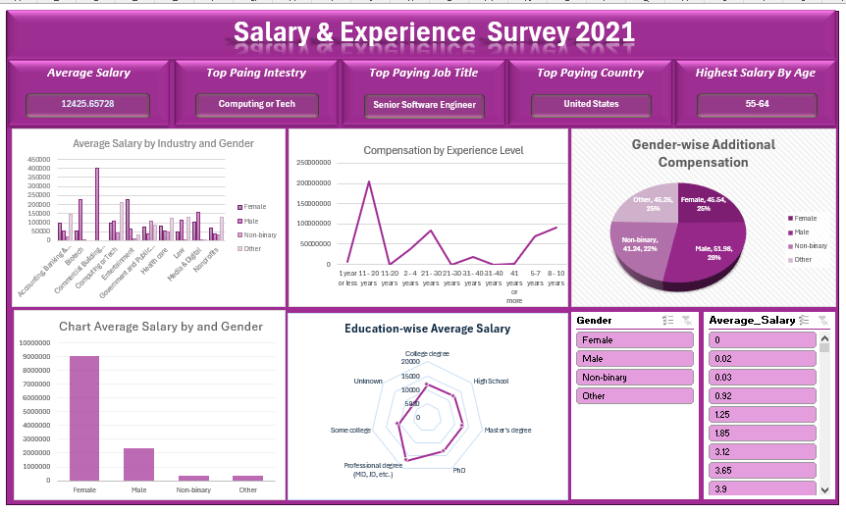

**10. Key Insights from Analysis**

1. Experienced professionals with over 10 years in the field earn nearly 2.5 times more than those with less than 3 years.

2. Interpretation, International Development, and Oil industries lead in average annual salaries.

3. Gender disparities are evident in over 60% of industries, with males earning 10 15% more than females in similar roles.

4. Professionals with Master's and College degrees consistently earn more.

5. Countries like the USA, Canada, and Australia offer the highest average compensation across job titles.

6. USD Currency are high earned salary current compare to others.

7. Common job titles reported include Director, Software Engineer, Project Manager, and Senior Software Engineer.

**11.Recommendations Based on Key Insights**

1. **Leverage Experienced Talent** – Companies should design retention programs and leadership tracks for professionals with over 10 years of experience, as their expertise drives higher value.
2. **Focus on High-Paying Industries** – Job seekers aiming for top earnings may prioritize career paths in **Interpretation**, **International Development**, and **Oil** sectors.
3. **Address Gender Pay Gap** – Organizations should conduct regular salary audits and implement equitable pay policies to reduce the **10–15% disparity** in over 60% of industries.
4. **Promote Higher Education Opportunities** – Employers can invest in tuition assistance or training programs to help employees obtain **Master’s** or **College degrees**, improving both skills and earning potential.
5. **Target High-Paying Markets** – Professionals seeking higher salaries may explore opportunities in **USA**, **Canada**, and **Australia**, while companies in these markets should offer competitive packages to attract global talent.
6. **Standardize Salary Reporting** – To avoid currency-related salary perception gaps, organizations should consider reporting compensation in a **common reference currency** like USD for global comparisons.
7. **Prioritize In-Demand Roles** – Career development programs should focus on skills for high-demand roles such as **Director**, **Software Engineer**, **Project Manager**, and **Senior Software Engineer**.

**12.Conclusion**

This project offered a complete journey through the data analytics lifecycle—starting with data cleaning, database integration, SQL querying, visualization in Excel, and dashboard creation. By analyzing global salary data, we revealed meaningful trends in compensation affected by experience, education, gender, and geography. The project highlights key trends and challenges in global career progression, offering actionable insights for job seekers, employers, and decision-makers alike.